UBND THÀNH PHỐ THỦ ĐỨC

**TRƯỜNG TH NGUYỄN VĂN BANH**

**TUẦN 34**

**REVIEW 1- UNIT 4,5,6**

1. **Read and circle.**
2. 

two / nine





one / four

1. drink / cookie

1. arms / fingers
2. **Read and match.**
3. 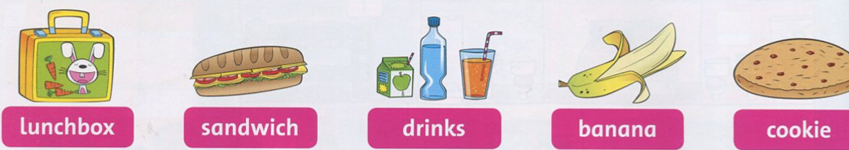tiger
4. 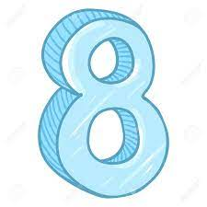eight
5. 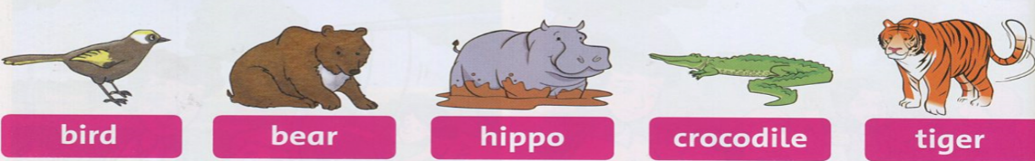pear
6. 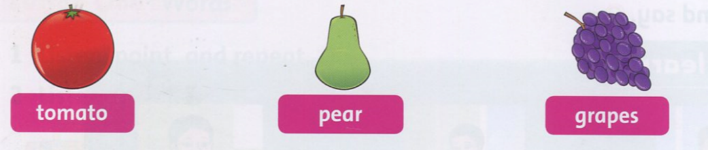sandwich
7. **Look and read. Put a tick (√) or a cross (x) in the box.**

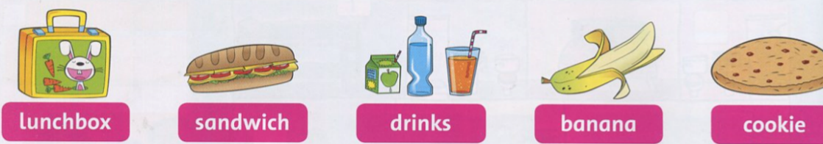

**√**

1. It’s a banana.

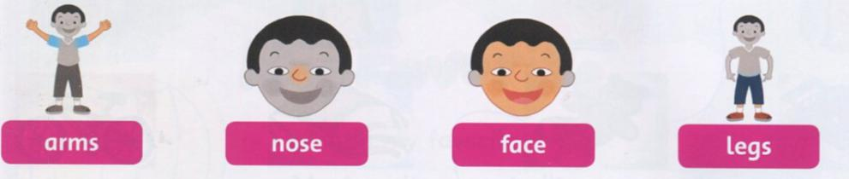

**X**

1. These are my legs.

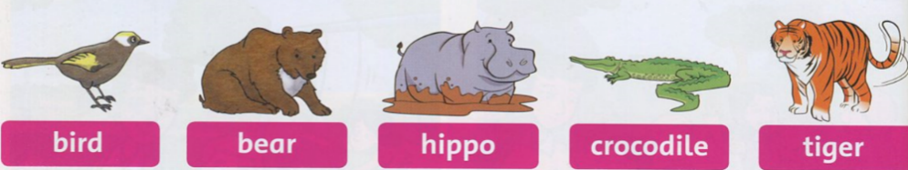

1. It’s a lion.

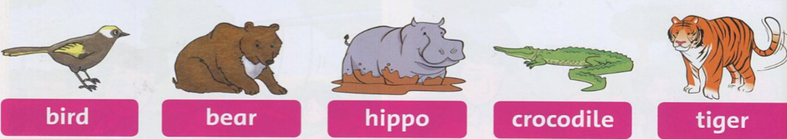

1. It’s a bear.

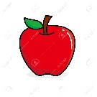

1. It’s an orange.
2. **Read and color.**

|  |  |
| --- | --- |
|  | The fish is yellow and orange. |
|  | The bird is blue. |